Wired Protocol - Ethernet
The IEEE 802.3 working group defines the specification for Ethernet. 100 MB/GB ethernet can be commonly found in different embedded development boards. Data rates up to 100Gbps over coaxial cable and 400Gbps over fiber optic cable have been proposed. It's power hungry but cheap enough and is even available as part of low cost embedded development boards.
Wireless - WiFi
Range: 100 meters
Rate: 1 Gbps
Power: Not Power Friendly
The number of devices connected to a single gateway depends on the available bandwidth, which will be divided between the connected clients and the processing power and memory of the system. In simple home devices, there can be up to 253 connections. WI-FI mainly operates in the 2.4 gigahertz ISM band, although 5 gigahertz and newer 60 gigahertz standards have been proposed. A newer standard, 802.11 Has been proposed in the 900 megahertz band. It will offer better range and power consumption. With the downside of lower bandwidth, this standard is targeted for the Internet of Things.
Bluetooth
It's a short-range, low bandwidth personal area network protocol. It operates in the unlicensed 2.4 gigahertz ISM band and uses frequency hopping spread spectrum.
Older Bluetooth: 3Mbits/s data rates
Newer Bluetooth 4.0: offers up to 34Mbits/s.
Bluetooth Smart, or Bluetooth Low Energy, or BLE is designed for very low power consumption. Despite the similar name to the classic Bluetooth, it's a completely different standard all together.
BLE – Bluetooth Low Energy
Data Rate: just 1Mbits/s, designed for sending periodic chunks of data
Encryption: BLE offers up to 128 bit AES encryption for messages. Here AES stands for the Advance Encryption Standard.
Benefit: With an approximate transmission power of 15 milliwatts, and 3 milliseconds per transaction, a BLE device can perform more than 20 million transactions within a small coin cell battery. Moreover, unlike in the classic Bluetooth, there is no theoretical limits on how many nodes can connect to one access point. Mesh networking is not supported, but is being considered to be made part of the standard.

ZigBee - Low Power Mesh Networking
Range: Although the range is up to a 100 meters, due to the mesh nature, it can offer
connectivity over longer distances.
Link Layer Standard: IEEE - 802.15.4 standard defined by IEEE, and unlike other connectivity protocols, it also defines the network and application layer protocol. All of this is part of the ZigBee protocol stack. The simple way to understand this is that in the ZigBee standard the connectivity or radio part is handled via IEEE 802.15.4 specifications, but the remaining logical parts like routing, security, data payload formats and profiling are done by the ZigBee alliance itself. For this reason, ZigBee is not only a connectivity protocol, but also a communication protocol.

RFID - Radio Frequency Identification
You can think of it as an advanced replacement for bar codes. Instead of a barcode on a product, there's a tag. And instead of light as in the case of a barcode reader, you use radio waves to interact with the tag. This means that you can have a longer range, and the tag doesn't have to be visible to be read. It can be implanted anywhere in the product, and as long as it's in the range of the reader, it can be tracked and read. At a minimum, tags have a chip, some kilobytes of memory, and antennae. Memories stores the information on the tag. The chip processes this data and performs the transformation functions. And the antenna is use to transmit and receive the RF signals. Tags can be passive or active. Passive tags take their power from the RF signals transmitted by the reader. Active tags have a battery that powers them. That's why active tags have a higher cost, but a longer range. A typical range for RFID usage is 1 meter.
Cellular Technologies
Cellular technologies is a very broad term and encapsulates a wide range of technologies. In simple terms, cellular technologies are those where there are multiple small interconnected transmitters or cells instead of one main transmitter. Another feature is frequency reuse, where one frequency is used by multiple cells to increase range and capacity. But these cells, have to be geography far apart from each other, so that there is minimal to no interference. The most common cellular technology is GSM. Most of the world's mobile network operators use GSM. GSM also has multiple standards classified as first, second, third generation and so on. The data rates and number of users per cell improves with each generation. The current deployed generation is fourth, or 4G, while 5G is in development. For every generation, you can have multiple competing standards. For example, for 4G, we have two main competitors, WiMax and LTE. A competing standard to GSM is CDMA. It's not used widely, and it's mostly limited to United States. In any case, your choice of technology can be based on the range you need, CDMA offers a better range, data rate, LTE offers a better data rate, local availability, whichever network is deployed in your area or cost.

6LoWPAN
6LoWPAN stands for IPv6 over low power wireless personal area networks. As the name suggests, it is a standard that enables the use of IPv6 on low power edge devices. By natively communicating using Internet Protocol, 6LoWPAN devices and networks don't require any special gateways to connect to other IP networks, such as the Internet. Therefore, 6LoWPAN offers interoperability and simplicity in design compared to ZigBee or Bluetooth. Essentially, this standard enables IPv6 packets to be transmitted over IEEE 802.15.4, which is a standard for low data rate wireless personal area networks. This makes 6LoWPAN ideal for cyber physical systems, where IP connectivity and low power consumption are essential.
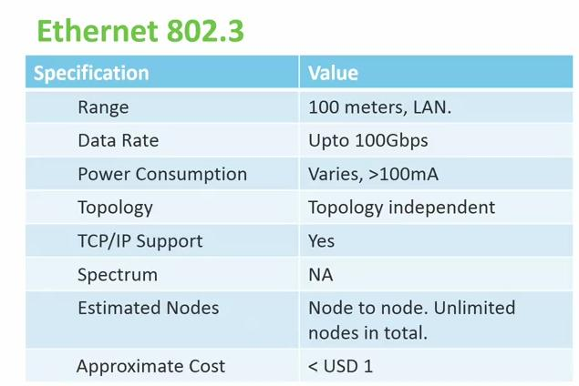  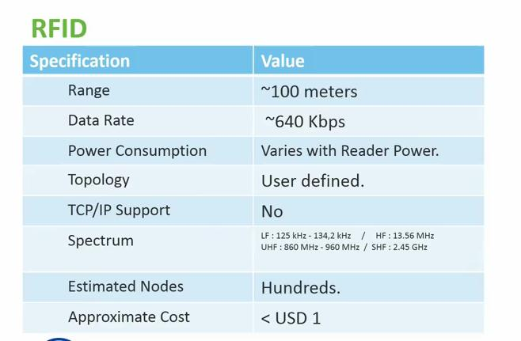  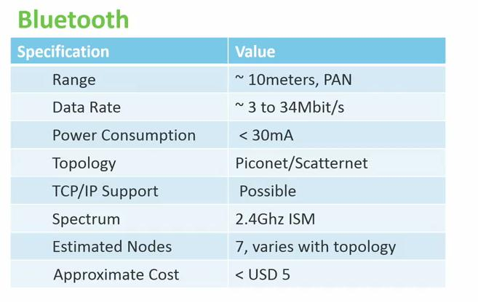  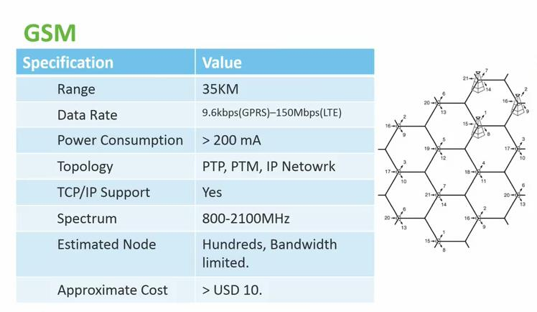 | 